**Homework 8:**

Does the test environment (independent variable), i.e. Lab (ID=1) or home (ID=0), have a significant influence on speech quality ratings (dependent variable)? Use the quality ratings of condition 3 provided in the file (lab_crowd_speech_quality).

**Step 1**:

To answer the question, we want to conduct an independent t-test where the independent variable consists of two categorical, independent groups “home” and “lab”. Check if the test requirement for an independent T-test are met.

1. there should not be any significant outliers in the dataset.
2. dependent variable should be approximately normally distributed for each group of the independent variable
3. homogeneity of variances: in SPSS, when conducting the independent T-Test, the Levene’s test will be computed as well. Based on the outcome of the homogeneity test, you will have to decide, which outcome of the t-test to interpret.

Analyze > Descriptive Statistics > Explore… > Add “Quality” to “Dependent List” and “Environment” to the “Factor List”

> Click on “Statistics…” button > In the “Statistics” modal, check the option “Outliers”

> Click on “Plots…” button > In the “Plots” modal check the option “Normality plots with tests” and under the “Descriptive”-section uncheck “Stem-and-leaf” and check “Histogram”

The Shapiro-Wilk test showed a significant departure from normality in both the “home” and “lab” conditions.

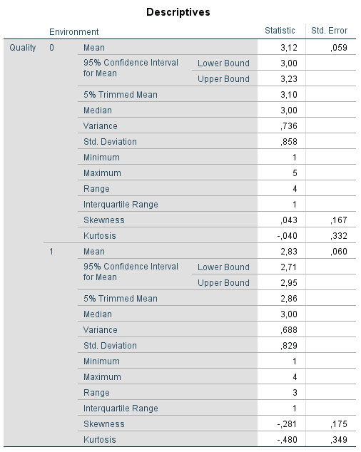

**Step 4**:

Conduct the independent t-test.

Analyze > Compare Means > Independent-Samples T Test… > Add “Quality” to “Test Variable(s)” list and “Environment” as the “Grouping Variable”. > Click on “Define Groups...” > For “Group 1” enter the value of the “home” environment type (0) and for “Group 2” the one of the “lab” environment type (1).

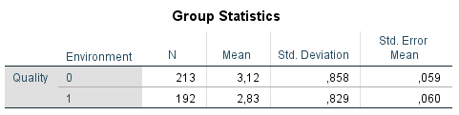

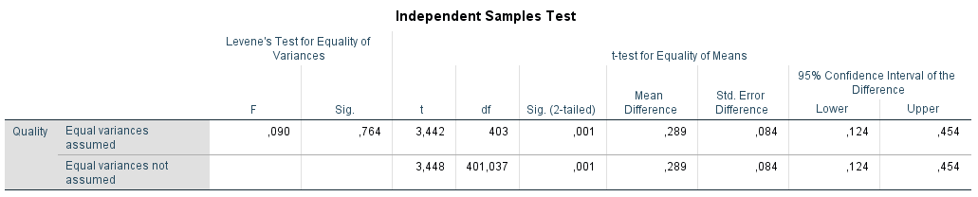

**Output interpretation**:

An independent-samples t-test was conducted to compare the speech quality ratings in home and lab conditions. Levene’s test for equality of variances indicated homogeneity of variances, F = .09, p = .764. There was a significant difference in the ratings for home (M= 3.12, SD= 0.858) and for lab (M= 2.83, SD= 0.829) conditions; t(403)=3.44, p=0.001. Persons performing the rating process at home assessed higher ratings to the test material compared to persons performing the test in the lab.